Subscriber

👤 What Is a Subscriber in a Mobile Network?
# Source: AI Source: Provided by: [Data Path: Persons Table -> ID Column: 1, Name_En Column: Motasem Essam] -> From: [ChatGPT] on [1/23/2026]
A subscriber is any individual or device that has an active mobile account with a mobile network operator (MNO) and uses its services — like making calls, sending SMS, or using mobile data.
📱 If you have a SIM card in your phone and a valid plan, you are a subscriber.

🧩 Key Elements of a Subscriber:
# Source: AI Source: Provided by: [Data Path: Persons Table -> ID Column: 1, Name_En Column: Motasem Essam] -> From: [ChatGPT] on [1/23/2026]
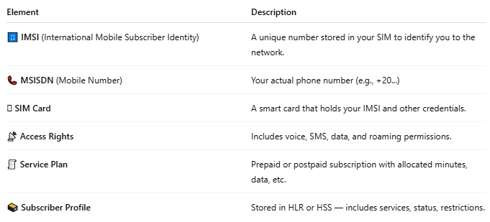

Element | Description
🔢 IMSI (International Mobile Subscriber Identity) | A unique number stored in your SIM to identify you to the network.
📞 MSISDN (Mobile Number) | Your actual phone number (e.g., +20...)
🪪 SIM Card | A smart card that holds your IMSI and other credentials.
📡 Access Rights | Includes voice, SMS, data, and roaming permissions.
🧾 Service Plan | Prepaid or postpaid subscription with allocated minutes, data, etc.
🗃️ Subscriber Profile | Stored in HLR or HSS — includes services, status, restrictions.

📶 What Does a Subscriber Do?
# Source: AI Source: Provided by: [Data Path: Persons Table -> ID Column: 1, Name_En Column: Motasem Essam] -> From: [ChatGPT] on [1/23/2026]
- 📞 Make and receive calls
- 💬 Send and receive SMS
- 🌐 Use mobile data
- 🔄 Roam in other networks
- 🔒 Get authenticated and authorized by the mobile system

🧠 Where Is Subscriber Info Stored?
# Source: AI Source: Provided by: [Data Path: Persons Table -> ID Column: 1, Name_En Column: Motasem Essam] -> From: [ChatGPT] on [1/23/2026]
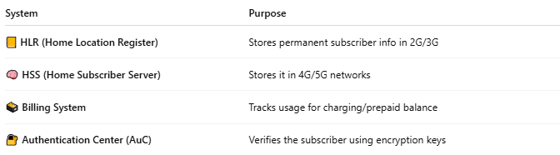

System | Purpose
📒 HLR (Home Location Register) | Stores permanent subscriber info in 2G/3G
🧠 HSS (Home Subscriber Server) | Stores it in 4G/5G networks
🗃️ Billing System | Tracks usage for charging/prepaid balance
🔐 Authentication Center (AuC) | Verifies the subscriber using encryption keys

🆚 Subscriber vs User:
# Source: AI Source: Provided by: [Data Path: Persons Table -> ID Column: 1, Name_En Column: Motasem Essam] -> From: [ChatGPT] on [1/23/2026]
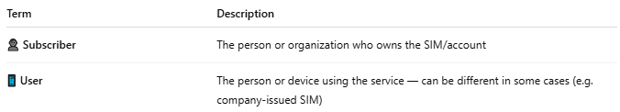

Term | Description
👤 Subscriber | The person or organization who owns the SIM/account
📱 User | The person or device using the service — can be different in some cases (e.g. company-issued SIM)

📖 Summary:
# Source: AI Source: Provided by: [Data Path: Persons Table -> ID Column: 1, Name_En Column: Motasem Essam] -> From: [ChatGPT] on [1/23/2026]
A subscriber is anyone who has:
- ✅ A valid SIM card
- 📞 An assigned mobile number (MSISDN)
- 📡 Registered on a mobile network
- 🧾 An active service plan
They are tracked, authenticated, and managed by systems like the HLR, VLR, and billing platform to ensure secure and accurate service delivery.

